**Alphabet Soup Charity Funding Predictor Report**

**Analysis Overview:**

The purpose of this analysis is to determine if it is possible to predict whether or not applicants for funding will be successful upon receipt of funding from the non-profit foundation Alphabet Soup, given the following data points:

* **APPLICATION_TYPE**—Alphabet Soup application type
* **AFFILIATION**—Affiliated sector of industry
* **CLASSIFICATION**—Government organization classification
* **USE_CASE**—Use case for funding
* **ORGANIZATION**—Organization type
* **STATUS**—Active status
* **INCOME_AMT**—Income classification
* **SPECIAL_CONSIDERATIONS**—Special consideration for application
* **ASK_AMT**—Funding amount requested

**Results:**

* **Data Preprocessing**
  + **What variable(s) are considered the target(s) for your model?** The target variable is the data point IS_SUCCESSFUL—Was the money used effectively or not by the organization
  + **What variable(s) are considered to be the features for your model?** The features are the data points noted above—various information collected about the organization and their application for funding that could potentially have an effect on the target variable. In order to obtain features the ML algorthim would understand, we needed to perform hot-one encoding on the categorical features and also binned some of the categorical features together to reduce noise while learning.
  + **What variable(s) are neither targets nor features, and should be removed from the input data?** Variables that were removed from the dataset were the identifying features of the organization (name & EIN) as they do not provide valuable information to analyze in their raw form
* **Compiling, Training, and Evaluating the Model**
  + **How many neurons, layers, and activation functions did you select for your neural network model, and why?** Originally I chose a Sequential model with an equivalent # of neurons to the # of features after the dataset had been pre-processed and 1 hidden layers to keep it simple. “ReLu” was chosen as the activation type for the learning and a “Sigmoid” activation for the final output layer which would correspond to the target of Successful or Not. This was a somewhat arbitrary starting point.
  + 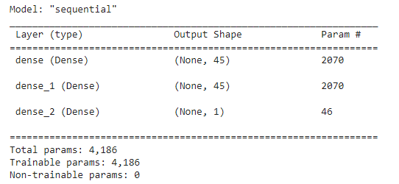
  + **What steps did you take to try and increase model performance?**  In order to try and increase model performance I used the keras hypertuning search with the following potential choices, which resulted in 180 trials:
    - **Layer activation type:** “relu” or “tanh”
    - **Layer units (neurons):** between 1 and 50
    - **Epochs:** up to 32
  + The best model chosen after hypertuning search had the following hyperparameters:
    - 'activation': 'tanh',
    - 'tuner/epochs': 32,
  + 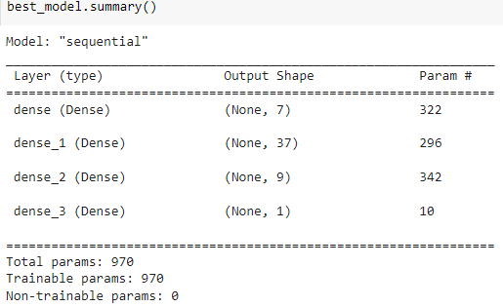
  + **Were you able to achieve the target model performance?** The final model chosen after nearly 200 different hypertuning trials still did not achieve a 75% accuracy, only 72.94% accuracy vs the original starting model with 72.8% accuracy. This difference is negligible.

**Summary**:

Overall, while the results were very close, I was not able to achieve the requested threshold of 75% accuracy in classification with a deep learning model. However, even 75% accuracy means that there is a large opportunity for inaccurate predictions by the model. The model results could still be useful in decision making for the charity, but would need to be taken with a grain of salt and used best by the charity as 1 factor in conjunction with other decision-making policies.

It is possible that a different type of model could better predict whether or not an organization will be successful in using received funds. I would recommend trying a Random Forest Classifier to attempt to solve this prediction problem as Random Forests have high accuracy in classification and simpler to implement.